
RAMAIAH
Institute of Technology
USN | 1 | M | S

(Autonomous Institute, Affiliated to VTU)
(Approved by AICTE, New Delhi & Govt. of Karnataka) Accredited by NBA & NAAC with ‘A’ Grade

SEMESTER END EXAMINATIONS – JUNE 2019

Course & Branch | : | B.E. : Computer Science and Engg / Information Science and Engg | Semester | : | IV
Subject | : | Engineering Mathematics - IV | Max. Marks | : | 100
Subject Code | : | CS/IS41 | Duration | : | 3 Hrs

Instructions to the Candidates:
- Answer one full question from each unit.

 |  | UNIT- I
1. | a) | Write the Simpson’s 3/8thrule. | CO1 | (02)
 | b) | Find the missing terms from the following data: | CO1 | (04)
   | 1 | 2 | 3 | 4 | 5
   | 11 | - | 40 | - | 140
 | c) | Use Newton’s divided difference formula to find f(0.5) from the following data: | CO1 | (07)
  x | 0 | 2 | 3 | 5 | 6
  f(x) | 0 | 6 | 21 | 105 | 186
 | d) | The following table gives the temperature in degrees centigrade of a cooling body at different instants of time in seconds.  Find the rate of cooling at 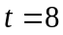sec. | CO1 | (07)
   | 1 | 3 | 5 | 7 | 9
   | 85.3 | 74.5 | 67 | 60.5 | 54.3
2. | a) | Obtain the expression for 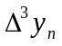 in terms of entries (- values) | CO1 | (02)
 | b) | A river is 80 ft wide, the depth of river “y” in ft at a distance “x” ft from the bank of the river is given by the following table. Find approximately the area of the cross section of the river using appropriate Simpson’s rule. | CO1 | (04)
  Distance from the bank of the river | 0 | 10 | 20 | 30 | 40 | 50 | 60 | 70 | 80
  Depth of the river | 0 | 4 | 7 | 9 | 12 | 15 | 14 | 8 | 3
 | c) | Find the number of men getting wages between Rs. 10 and Rs. 15 from the following data: | CO1 | (07)
  wages | 0 – 10 | 10 - 20 | 20 - 30 | 30 - 40
  No. of men | 9 | 30 | 35 | 42
 | d) | Find a root of the equation 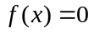from the following data using the Lagrange’s Interpolation formula | CO1 | (07)
   | 2.2 | 2.4 | 2.6 | 2.8
  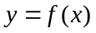 | - 0.45 | - 0.29 | - 0.12 | 0.05
 |  | UNIT- II
3. | a) | Write pdf of binomial distribution and explain the terms involved. | CO2 | (02)
 | b) | If 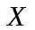is an exponential variate with mean 5, evaluate (i)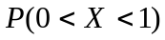(ii)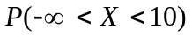 | CO2 | (04)
 | c) | The probability distribution of a finite random variate X is given by the following table:  (i) Find the value of k, (ii) Find 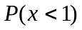 (iii) 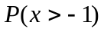  (iv) 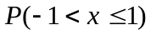 (v) calculate the mean and variance. | CO2 | (07)
   | -2 | -1 | 0 | 1 | 2 | 3
  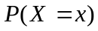 | 0.1 | K | 0.2 | 2k | 0.3 | k
 | d) | The life of a certain type of electrical lamps is normally distributed with mean 2040 hours and standard deviation 60 hours. In a consignment of 3000 lamps, how many would be expected to burn for (i) more than 2150 hours (ii) less than 1950 hours and (iii) between 1920 and 2160 hours, given that A(1.5) = 0.4332, A(1.8) = 0.4641 and A(2) = 0.4772. | CO2 | (07)
4. | a) | Write pdf of normal distribution and explain the terms involved. | CO2 | (02)
 | b) | The probabilities of a Poisson variate taking the values 3 and 4 are equal. Find the pmf of the variate, mean and variance. | CO2 | (04)
 | c) | A random variable X has the following density function: 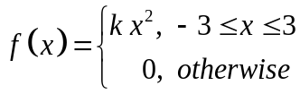  Find (i) value of k (ii) P(1 ≤ X ≤ 2) (iii) P(X ≤ 2) (iv) P(X > 1). | CO2 | (07)
 | d) | Derive mean and standard deviation of Gamma distribution. | CO2 | (07)
 |  | UNIT- III
5. | a) | Define joint probability distribution of X and Y in discrete case. | CO3 | (02)
 | b) | Find the autocorrelation and correlation coefficient of X(t) with  the random process: | CO3 | (04)
  Outcome | 1 | 2 | 3 | 4 | 5 | 6
  X(t) | -4 | -3 | 1 | 2 | -t | t
 | c) | Two cards are selected at a random from a box which contains five cards numbered 1, 1, 2, 2 and 3. Find the joint distribution of X and Y, where X denoted the sum and Y the maximum of the two numbers drawn. Also determine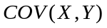. | CO3 | (07)
 | d) | Show that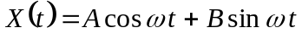, where and are  uncorrelated random variables each with mean 0 and variance 1 and is a positive constant is a WSS. | CO3 | (07)
6. | a) | Define stochastic process. | CO3 | (02)
 | b) | Find the joint distribution of X and Y, which are independent random variables with the following respective distributions also find E(X) and E(Y). | CO3 | (04)
   | -2 | 5 | 8
   | 0.3 | 0.5 | 0.2
  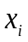 | 1 | 2
  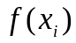 | 0.7 | 0.3
 | c) | If the probability function of the random variables X and Y is given by 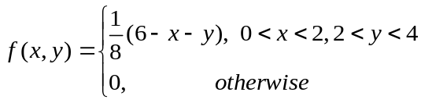  Find (i) 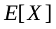 and 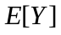(ii) 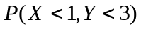(iii) 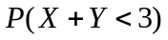 | CO3 | (07)
 | d) | A stochastic process with its ensemble functions are assumed to have equal probabilities are given: by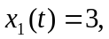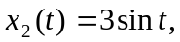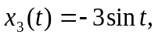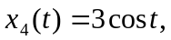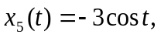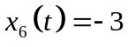. Show that the process is WSS but not SSS. | CO3 | (07)
 |  | UNIT- IV
7. | a) | Define Absorbing state and Recurring state of a Markov chain. | CO4 | (02)
 | b) | Trains arrive at the yard every 15 minutes and the service time is 33 minutes. If the line capacity of the yard is limited to 5 trains, find the probability that the yard is empty and the average number of trains in the system. | CO4 | (04)
 | c) | A telephone exchange receives one call for every 4 minutes and connects one call for every 3 minutes. If the rate of arrivals follows Poisson distribution and service time follows exponential distribution find (i) Expected waiting time for a call. (ii) Expected time in the system. (iii) Expected no. of customers in the system. (iv) Expected no. of customers in queue. | CO4 | (07)
 | d) | A player has Rs.300. At each play of a game, he loses Rs.100 with probability ¾ but wins Rs.200 with probability ¼. He stops playing if he has lost his Rs.300 or he has won at least Rs.300. (i) Determine the transition probability matrix of the Markov chain (ii) Find the probability that there are at least 4 plays to the game. | CO4 | (07)
8. | a) | Define M/M/1 queuing system. | CO4 | (02)
 | b) | Find the fixed probability vector of the stochastic matrix 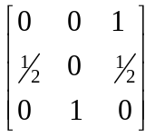. | CO4 | (04)
 | c) | Two boys’ b₁ and b₂ and two girls g₁ and g₂ are throwing a ball from one to the other. Each boy throws the ball to the other with probability ½ and to each girl with probability ¼. On the other hand, each girl throws the ball to each boy with probability ½ and never to the girl. In the long run, how often does each receive the ball? | CO4 | (07)
 | d) | A departmental store has a single cashier. During the rush hours, customers arrive at the rate of 20 customers per hour. The average number of customers that can be processed by the cashier is 24 per hour. Find (i) What is the probability that the cashier is idle? (ii) What is the average number of customers in the system? (iii) What is the average time that a customer spends in the system? (iv) What is the average number of customers in the queue? (v) What is the average time a customer spends in the queue, waiting for service? | CO4 | (07)
 |  | UNIT- V
9. | a) | Define F-distribution. | CO5 | (02)
 | b) | A machinist is making engine parts with axle diameter of 0.7 inch. A random sample of 10 parts shows mean diameter 0.742 inch with a Standard Deviation of 0.04inch. On the basis of the sample, would you say that the work is inferior? | CO5 | (04)
 | c) | A population consists of the four numbers 3, 7, 11, 15. Consider all possible samples of size 2 which can be drawn (i) with replacement and (ii) without replacement from this population. In both the cases find (a) the population mean (b) the population standard deviation (c) the mean of the sampling distribution of means (d) the standard error of means. | CO5 | (07)
 | d) | Fit a Poisson distribution for the following data and test the goodness of fit. | CO5 | (07)
  x: | 0 | 1 | 2 | 3 | 4 | 5 | 6
  f: | 273 | 70 | 30 | 7 | 7 | 2 | 1
10 | a) | Write formula for χ² test and explain the terms involved. | CO5 | (02)
 | b) | Two sample sizes 8 and 7 give the sum of squares of deviations from their respective means equal to 34 and 24 respectively. Test the hypothesis that the populations have the same variance given that F_{0.05}=4.2 for (7,6) degrees of freedom. | CO5 | (04)
 | c) | A group of 10 rats fed on a diet A and another group of 8 rats fed on a different diet B recorded the following increase in weights in gms.  Test whether the diet A is superior to diet B. | CO5 | (07)
  Diet A | 5 | 6 | 8 | 1 | 12 | 4 | 3 | 9 | 6 | 10
  Diet B | 2 | 3 | 6 | 8 | 1 | 10 | 2 | 8 | - | -
 | d) | The theory predicts that the proportion of beans available in four groups A, B, C, D should be 9:3:3:1. In an experiment with 1600 beans the numbers in the four groups were 882, 313, 287 and 118. Use - test to verify whether the experimental result supports the theory. | CO5 | (07)

****************

